SHIPPING REQUEST FORM
Globilty Link Inc.
1201-2100 Sherobee Rd
Mississauga, ON L5A4C5
P: 647-557-8972 CN
P: 727-388-1380 US
Fax: 919-400-4860 International

TCS#

Location Name:

Location Address:

Merchants Phone: ( ) -

Sales Office: Globility Link Inc.

Terminal Model:

Terminal Serial Number: Pin-Pad Serial Number:

Password: 111111 Surcharge: N/A Halo:

Quick Cash: N/A

Via UPS: (Select One)

Ship To:

Business Name:

Address:

Phone: ( ) -

Attention:

For internal use only:
Confirm Shipping to jwi@gloilitylink.com Ship Date: ___/___/_____

Paid By: (Select One)
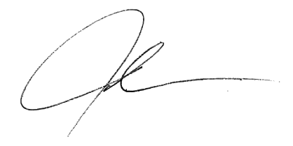

Authorized Signature: _________________________

